**C++ Coding task – Spot price simulation**

**Task**

In C++ write a program that computes the future spot price for an equity using the Black-Scholes-Merton model. This should generate random paths by geometric Brownian motion according to the specification below. Your solution should be documented and should be designed to be extensible.

**Specification**

Your solution should meet the following specification:

* The program should take the following as inputs: Current stock price, risk-free rate, stock volatility, time to maturity.
* The simulation should enable the following to be specified: Number of random paths, number of time points per simulation path.

The solution should be able to output the following:

* Full history of all simulated paths, an example is shown below in Figure 1.
* The expected potential exposure and 95% potential future exposure profiles.
* Program execution metrics such as total time to execute.

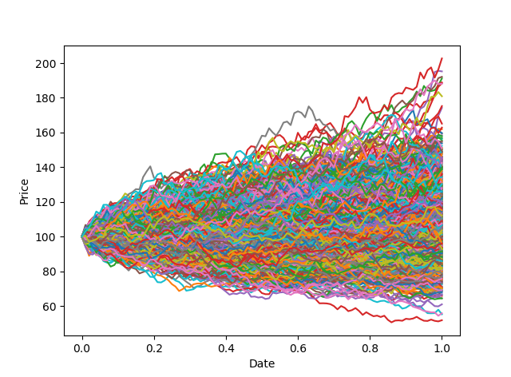

**Figure 1** – Simulated random paths using the Black-Scholes-Merton model.